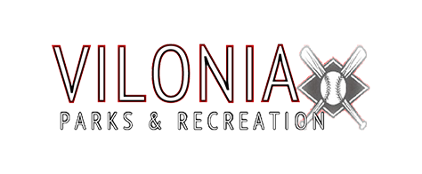

Umpire Information for Vilonia Baseball/Softball League
2018

Age Requirement: 16 years of age or older
Start Date: April 7th, 2018
End Date: June 17th, 2018
Days of the Week: Every Monday, Tuesday, and Thursday of each week. Also, there are a few tournaments that umpires will be needed on Friday’s and Saturday’s
Pay Information: You will be paid on a game by game basis, with each age group possibly having a different pay rate. Payment will be by check, and is biweekly.
Umpire Certification Info: to be able to umpire in our league this year, you will need to be certified through USSSA. You can easily go online to the following website to get certified:
https://www.usssa.com/baseball/OfficialsHome/
Additional Qualifications: New this year, all umpires will be required to attend an umpiring clinic held by Chase Lewis and Jon Alexander. More information about this clinic will be posted online, and sent to all applicants by phone or email, when it becomes available.
How to Apply: If you meet all the qualifications above and are interested in applying to umpire for the 2018 season, you can apply:
- At City Hall in Vilonia, ask for Amanda Norwood and she will provide you with an application.
- Online at, http://leagues.bluesombrero.com/Default.aspx?tabid=945593
and find the link to Umpire Application, or scan the QR code at the bottom of the page and it will take you to Vilonia Parks and Recreation website where you can find the link to the Umpire Application as well.

FOR MORE INFORMATION CONTACT:
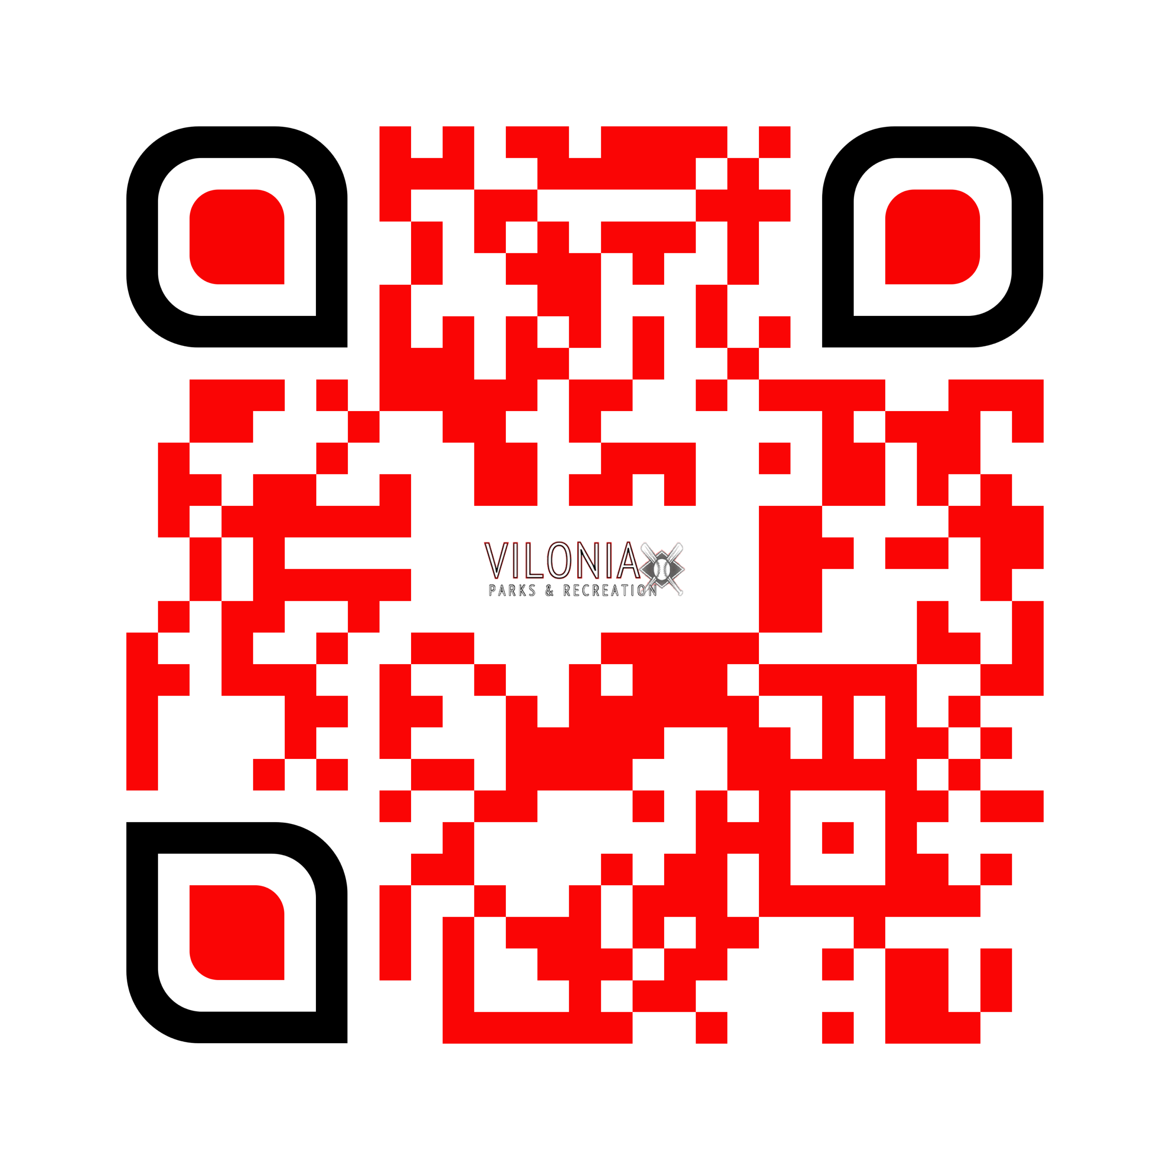
JOHNNY ALEXANDER @ 501-428-4701, or johnny.alexander@cityofvilonia.org
OR,
TREY LEWIS @ 501-514-8284, or tlew2433@icloud.com

